**Lab Exam Exercise Report: Network Topology using RIP and OSPF**

**Introduction**

This report documents the steps taken to configure a network topology using RIP v1 and OSPF routing protocols in Cisco Packet Tracer. The objective of the lab was to design a network with two LANs connected by two routers, each using a different routing protocol, and to ensure successful communication between the LANs. The configuration was tested through simulation to verify correct message transmission between the LANs.

**Network Topology Design**

The network topology consisted of two Local Area Networks (LANs), each containing five computers connected to a switch. Each LAN was connected to a router, and the two routers were connected via a Wide Area Network (WAN) link.

* **LAN 1**:
  + 5 PCs connected to Switch 1
  + Router 1 connected to Switch 1 and configured with RIP v1
* **LAN 2**:
  + 5 PCs connected to Switch 2
  + Router 2 connected to Switch 2 and configured with OSPF

The two routers were connected via a WAN link using a serial connection.

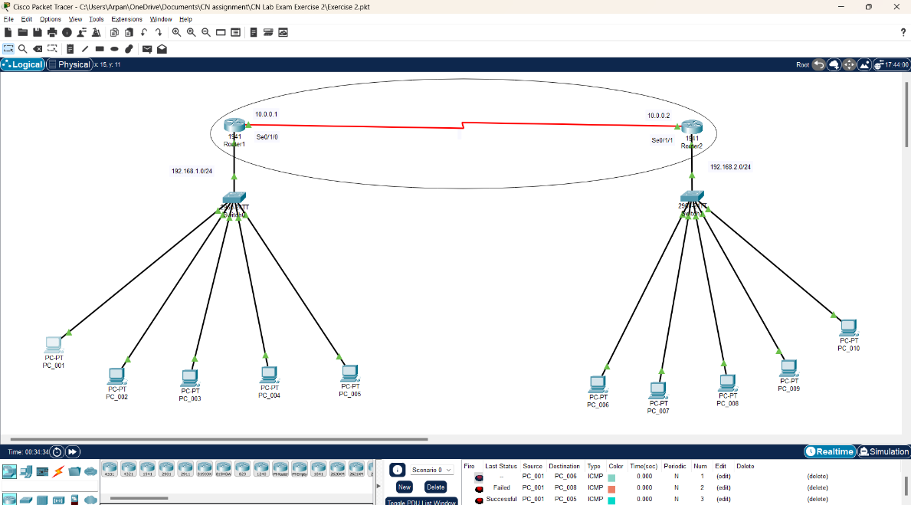

**IP Address Configuration**

Each LAN was assigned a unique subnet for its devices. The last three digits of the roll number were used as the last octet in the IP addresses assigned to the PCs.

* **LAN 1 (192.168.1.0/24)**:
  + IP addresses of PCs: 192.168.1.xxx, where xxx is the last three digits of the roll number
  + Router 1 LAN interface: 192.168.1.1
* **LAN 2 (192.168.2.0/24)**:
  + IP addresses of PCs: 192.168.2.xxx
  + Router 2 LAN interface: 192.168.2.1
* **WAN (192.168.10.0/30)**:
  + Router 1 WAN interface: 192.168.10.1
  + Router 2 WAN interface: 192.168.10.2

**Routing Protocols Configuration**

Router 1 was configured to use RIP v1 for routing, while Router 2 was configured with OSPF. The following steps were followed to configure the routers:

* **Router 1 (RIP v1)**:
  1. Enable RIP protocol
  2. Configure RIP v1
  3. Add networks 192.168.1.0 and 192.168.10.0

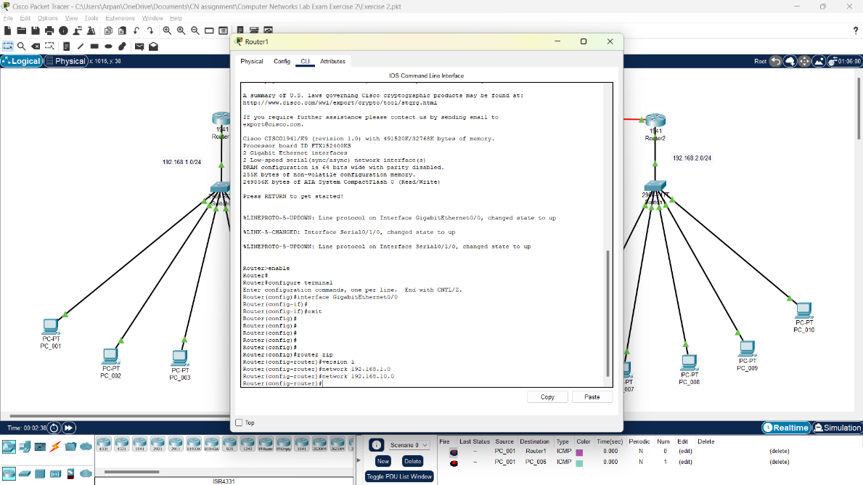

* **Router 2 (OSPF)**:
  1. Enable OSPF protocol
  2. Assign OSPF to Area 0
  3. Add networks 192.168.2.0 and 192.168.10.0

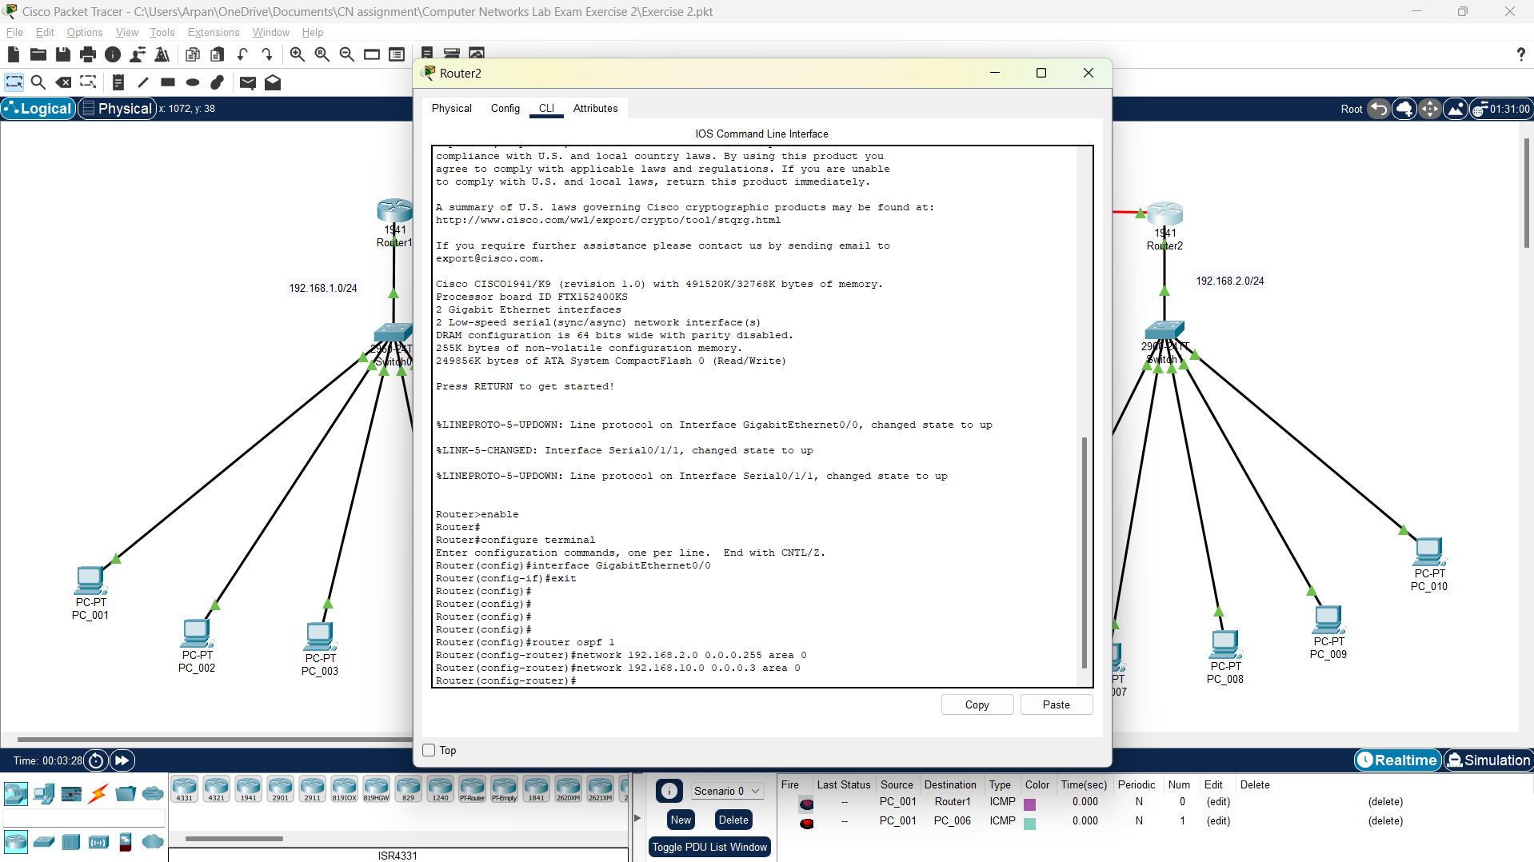

**Packet Tracer Simulation**

Cisco Packet Tracer’s simulation mode was used to test communication between devices in LAN 1 and LAN 2. The ping and traceroute commands were used to verify that packets were successfully routed between the networks.

**Conclusion**

In this lab, a network topology was successfully configured using RIP v1 and OSPF routing protocols. IP addressing, router configurations, and routing protocols were set up to allow communication between the LANs. The configuration was validated through simulation in Cisco Packet Tracer, confirming that the routers were able to route packets between LAN 1 and LAN 2 correctly.